**Binary Incrementer**

**The increment microoperation adds one to a number in a register. For example if a 4-bit register has a binary value 1101, it will go to 1110 after it is incremented.**

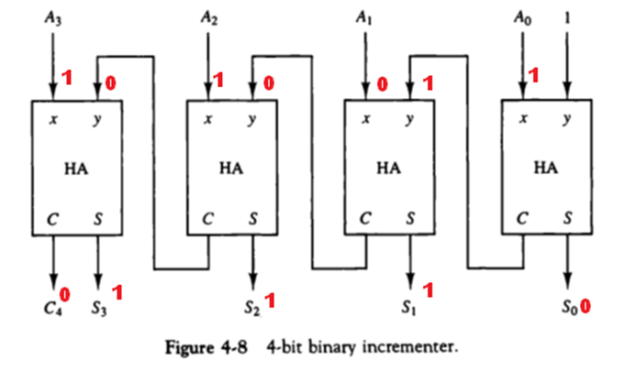

**The diagram of a 4-bit combinational circuit incrementer is shown in fig.4-8. One of the inputs to the least significant half-adder is connected to logic-1 and other input is connected to the least significant bit of the number to be incremented. The outut carry from one half-adder is connected to one of the inputs of the next higher order half-adder.**

**The circuit receives the four bits from A0 through A3, adds one to it, and generates the incremented output in S0 through S3.**

**The circuit of fig. 4-8 can be extended to an n-bit binary incrementer by extending the diagram to include n half-adders. The least significant bit must have one input connected to logic-1.The other inputs receive the number to be incremented or the carry from previous stage.**

**Example:**

